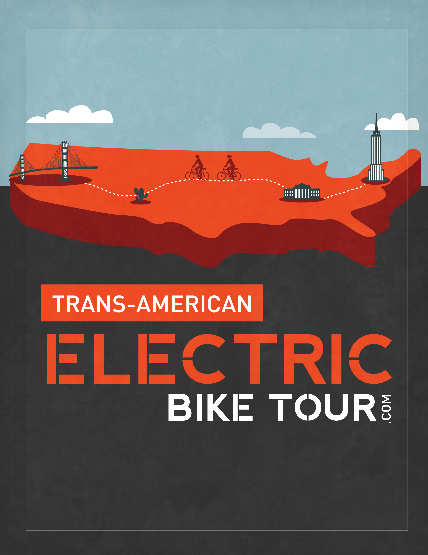

Press Release Media Contact:
Boris Mordkovich
boris@evelo.com
347-225-1849
EVELO Announces 4,000 Mile Trans-American Electric Bike Tour
Team will average 1,000 MPG cross-country with electric bicycles
NEW YORK, NY – With the cost of gasoline at a record high and public transportation fares increasing, can you imagine a vehicle travelling up to 1,000 miles for the cost of a gallon of gas? We can. EVELO, Inc. (www.evelo.com), a New-York-based electric bicycle company, is launching an electric bike line and will prove the claim by sending a team to ride 4,000 miles from New York to San Francisco. The real cost of the energy? Less than $20 worth of electricity.
Electric bicycles contain an integrated electric motor and battery and can travel up to 40 miles on a single charge costing 6-10 cents. The rider can switch between pure pedaling, pedal-assist, or electric-only modes.
The Trans-American Electric Bike Tour (www.transamericanelectricbiketour.com) will promote electric bikes (or e-bikes) as an alternative mode of transportation for commuting and recreation. The tour departs April 7, 2012 from New York City and ends in San Francisco two months later, with stops at more than 15 cities to host presentations and talks. Coinciding with Earth Week in April and Bike to Work Week in May, the tour will help raise awareness of how electric bikes can make a bike-centered commute possible in any terrain and ease the transition for those wanting to exercise by bike.
Team members Boris Mordkovich and Anna Mostovetsky are long-time cyclists and proponents of environmentally friendly, efficient, green transportation. They will travel the entire journey on two electric bicycles provided by EVELO, pulling Burley trailers for gear and supplies. The bikes are equipped with NuVinci® drivetrains to ease shifting, optimize motor performance and ultimately increase battery range. The initiative is also sponsored by Airbnb.com, a global network of local accommodations.
“Over the last decade, electric bike use has grown by leaps and bounds, becoming an integral way of transportation in much of Europe and Asia,” says Boris Mordkovich, co-founder of EVELO and Trans-American team leader. “Our objective is to show US consumers the electric bicycle technology that the rest of the world has fully embraced.”
To learn more about the tour and electric bicycles, and to see if the tour will travel through your city, join in the conversation at www.transamericanelectricbiketour.com and www.EVELO.com.
About EVELO Electric Bicycles
EVELO Electric Bicycle Company develops long-range, stylish electric bicycles for recreation and commuting. Their mission is to get more people cycling more often by making bicycles accessible and simple to use. Learn more about EVELO at www.EVELO.com.

Short & Long Description

LONG DESCRIPTION (137 words)

The Trans-American Electric Bike Tour is a coast-to-coast bicycle tour whose objective is to spread awareness about hybrid electric bicycles. On April 7, two cyclists will depart from New York to travel 4,000 miles to San Francisco, riding electric bicycles provided by a NYC-based company – EVELO (www.evelo.com).
The cyclists will average 80 miles per day and the entire distance will be accomplished with less than $20 of electricity (an equivalent of 1,000 MPG). Along the way, the riding team will make stops in approximately 15 cities to provide demonstrations of the bikes and host discussions about the benefits of electric bikes.
Electric bicycles offer a new way for people to commute and get around town on bicycles, regardless of the terrain, age or fitness levels. To learn more and follow the progress of the tour, visit www.TransAmericanElectricBikeTour.com.

SHORT DESCRIPTION (83 words)

The Trans-American Electric Bike Tour is a coast-to-coast bicycle tour whose objective is to spread awareness about hybrid electric bicycles. On April 7, two cyclists will depart from New York to travel 4,000 miles to San Francisco, riding electric bicycles provided by a NYC-based company – EVELO (www.evelo.com).
Electric bicycles offer a new way for people to commute and get around town on bicycles, regardless of the terrain, age or fitness levels. To learn more and follow the progress of the tour, visit www.TransAmericanElectricBikeTour.com.
USEFUL LINKS:
Blog: www.transamericanelectricbiketourcom
Facebook: http://www.facebook.com/iloveevelo/
Twitter: https://twitter.com/#!/evelobikes
Google +: https://plus.google.com/u/0/b/105444201441217972515/105444201441217972515/posts

Factsheet

Event Name: Trans-American Electric Bike Tour
Organizer: EVELO Electric Bicycles (New York)
Full Description: A cross-country electric bicycle tour with the objective of spreading awareness of the advantages of electric bicycles to American consumers.
Start Destination: Starts in New York City, New York (Prospect Park, Brooklyn)
End Destination: Ends in San Francisco, California
Start Date: Saturday, April 7, 2012 at 11:30 am
End Date: Wednesday, June 20, 2012
Who’s Cycling: Boris Mordkovich, New York; Anna Mostovetsky, Washington
Average Cycling Distance Per Day: 80 miles
Estimated Cycling Days: 50 (remaining days will be used for events and rest)
Bicycles: EVELO Aries and EVELO Aurora. Each equipped with a 250W Mid-Drive motor and 36V10Ah Lithium-Polymer Battery. Further details here:
- Aries: http://www.evelo.com/electric-bicycles/aries/
- Aurora: http://www.evelo.com/electric-bicycles/aurora/
Bicycle Range: Each battery is capable of travelling up to 40 miles on pedal-assist mode on a single charge. Each rider will carry a second battery to extend the daily range.
Battery Recharge Time: 4-6 hours to full capacity
Electricity Cost Per Charge: Average is $0.08 cents
Cost To Ride 4,000 Miles: Ultimately, it depends on how much the rider engages the motor. However, if the entire trip were taken on electric power alone, the 4,000 miles would use $16 to $20 worth of electricity. For that same $20, you could purchase 4-5 gallons of gas, giving you the equivalent of 1,000 miles per gallon.
Additional Gear Used: NuVinci N360™ Drivetrains have been included to assist in shifting, improve motor performance and increase battery range. Burley trailer for moving supplies and equipment.
Support Vehicle: The trip is entirely self supported with no support vehicle.
Sponsors: EVELO Electric Bicycles, Airbnb, Burley
Planned Route/Stops: Map available here: http://batchgeo.com/map/345a92a01131122816aba36c7efea501

Factsheet (continued…)

Cities The Tour Will Pass Through:
April 7 New York City, NY
April 8 Philadelphia, PA
April 9 West Chester, PA
April 10 Baltimore, MD
April 11 Annapolis, MD
April 12 Washington, DC
April 17 Pittsburgh, PA
April 18 Akron, OH
April 22 Ann Arbor, MI
April 26 Chicago, IL
April 27 Milwaukee, WI
April 30 Madison, WI
May 3 Cedar Rapids, IA
May 4 Des Moines, IA
May 8 Omaha, NE
May 21 Denver, CO
May 22 Boulder, CO
May 23 Longmont, CO
May 24 Fort Collins, CO
June 4 Salt Lake City, UT
June 14 Carson City, NV
June 17 Sacramento, CA
June 19 Davis, CA
June 21 San Francisco, CA

Who Is Team EVELO?

Boris Mordkovich is an avid cyclist and a serial entrepreneur specializing in technology and alternative transportation. With EVELO (www.evelo.com), an electric bicycle company based out of New York, he plans to make cycling more accessible and to get more people cycling more often.
Prior to EVELO, Boris helped launch RelayRides – the world’s first person-to-person carsharing organization – which gathered a $13M investment from Google and has expanded to multiple cities across the US. He has also contributed to Tour d’Afrique, a bicycle adventure company organizing and leading trans-continental cycling expeditions in Africa and other remote destinations.
Boris is the primary organizer and lead rider on the Trans-American Electric Bike Tour. His previous tour and expedition experience includes a crossing of New Zealand by bicycle in 2008. In 2011, he put together a team who travelled the African continent, completing a 27,000 km journey from Cape Town to London by Land Rover.

Anna Mostovetsky is an environmental scientist who loves the outdoors, as well being a seasoned bicycle enthusiast.
She received her degree in Environmental Science from SUNY College of Environmental Science and Forestry, and has held a number of interesting field jobs since. Anna has worked on a trail maintenance crew in the back country of Colorado, had a stint as a Park Ranger in Washington’s remote Cascade Mountains, collected hydrology data in the forests of the Sierra Nevada, and most recently, restored wild habitat for Pacific Northwest salmon. When she’s not roaming the woods during work hours, you can usually find her foraging and hiking in the mountains or buzzing around town on her bike.
Because of her love for conservation, restoration, and the natural world, Anna is conscious of our growing need as a society to make smarter, environmentally focused choices. This includes using alternative methods of accessible transport that appeal to a wide variety of people. As a cyclist and bike fanatic, she is excited about spreading the word on electric bicycles to a new cadre of riders and commuters.
Anna lives in Washington State and is the second rider in the Trans-American Electric Bike Tour. Her previous touring experience includes a New Zealand bike expedition in 2008. Other recent travels include a four-month journey through Peru and Ecuador, hopping buses and cramming herself into the tight corners of passenger vans already at maximum capacity. She’s looking forward to the wide open spaces as Team EVELO traverses across this great country of ours!

Objectives

The objectives for the trip are as follows:

1. Increase Awareness
Our objective is to expose more people throughout the entire country to electric bicycles and their benefits with the help of the press, social media, and support of the folks we’ll meet along the way.

2. Prove It
We want to prove and demonstrate that electric bikes are a reliable and extremely efficient form of urban transport, and no longer a new and untested mode of transportation. If we can travel for 4,000 miles, then the bikes will prove themselves capable of any commute or recreational trip you may choose to challenge them with.

3. Collect and Exchange Best Practices
We want to gain an understanding of how cycling and electric vehicles in general can impact urban transportation in different cities throughout the country and share that knowledge on and beyond this trip. From New York City to San Francisco and everywhere in between – we will accumulate best practices and share them with others.

Industry Statistics

Sales of Electric Bikes in the U.S:
2005 - 100,000
2008 - 170,000
2010 - 150,000 (actually retreated a bit due to lower gas prices)
2016 Projections: 785,000

Sales of Electric Bikes in Europe:
2009 - 500,000
2010 - 700,000

Sales of Electric Bikes in China:
2002 – 1,500,000
2003 – 4,000,000
2009 – 22,000,000
2010 – 28,000,000

Projected Sales of Electric Bikes Worldwide:
2012 – 30,000,000
2018 – 47,000,000
“…the worldwide market for e-bicycles will increase at a compound annual growth rate (CAGR) of 7.5% between 2012 and 2018, resulting in global sales of more than 47 million vehicles in 2018...”
Source: http://www.pikeresearch.com/newsroom/annual-sales-of-electric-bicycles-will-surpass-47-million-by-2018-2
Target Market: Urban commuters, particularly those traveling long distances, and Baby Boomers who may have lost a gear or two, but still want to ride.
Industry Developments: First-ever electric bike sharing is currently being launched in San Francisco by City Carshare with a grant from the Department of Transportation.
% of Americans Who Currently Bike to Work: The American Community Survey tells us that just 0.55% of the working population in the U.S., age 16 and older, bikes to work.

Sponsors

EVELO
EVELO Electric Bicycle Company develops long-range, stylish electric bicycles for recreation and commuting. Their mission is to get more people cycling more often by making bicycles accessible and simple to use. Learn more about EVELO at www.EVELO.com.

Airbnb
Airbnb is a global network of accommodations offered by real people in 19,732 cities in 192 countries, totally more than 100,000 properties. Airbnb has generously sponsored accommodations across the US for Team EVELO, so they can stay with friendly locals each night of the tour.

Burley
Burley is a leading manufacturer of bike trailers designed to carry children and cargo. They even have an item designed especially for bike commuters to help securely carry a laptop and change of clothes! The team will be using the trailers to pull their own equipment, gear, and cargo throughout the trip.

Support Team

Pulling off a 4,000 bike tour successfully requires a team of people. Team EVELO includes the following:

Riders:
- Boris Mordkovich (boris@transamericanelectricbiketour.com)
- Anna Mostovetsky (anna@transamericanelectricbiketour.com)

Support Team:
- Eugene Mordkovich – equipment and logistics (eugene@transamericanelectricbiketour.com)
- Frances Krug – blog management and administration (frances@transamericanelectricbiketour.com)

